Experiment No. 7

Title: Implementation of 3 bit synchronous up-down counter using JK flips flops

Batch: B1 Roll No.: 1914078 Experiment No.: 7

Aim: Implementation of 3 bit synchronous up-down counter using JK flips flops _______________________________________________________________ ___ _
Resources needed: Simulation Software, (Proteus Professional 8).

Theory:

Synchronous Counter Operation
Synchronous counters have a common clock pulse applied simultaneously to all flip-flops.

A 2-Bit Synchronous Binary Counter
Note that both the J and K inputs are connected together. The flip-flop will toggle when both are a 1 (FF0) Also the transition at clock pulse 2 works because of propagation delay effects. Q0 is still high on the input of Q1 at the instant clock 2 hits so FF1 changes state. A short time later clock 2 has propagated through FF0 and it goes low.

Truth table of J K flip flop
Inputs |  |  | Outputs |  | comments
J | K | CLK | Q₁ | Q’₁ | comments
0 | 0 | ↑ | Q₀ | Q’₀ | No change
0 | 1 | ↑ | 0 | 1 | Reset
1 | 0 | ↑ | 1 | 0 | Set
1 | 1 | ↑ | Q’₀ | Q₀ | Toggle

Design procedure of Synchronous counter
- Find the number of flip-flops.
- Write the count sequence in tabular form
- Determine the flip-flop inputs which must be present for desired next state from the present state using excitation table of the flip-flops.
- Prepare K-map for each flip-flop input in terms of flip-flop outputs as the input variables.
- Simplify the K-maps and get the minimized expressions for each flip-flop input.
- Connect the circuit using flip-flops and other gates corresponding to the minimized expression

Design A 3-Bit Synchronous up- down Binary Counter using JK flip-flops: (Include the timing diagram)
Solution: (Create a soft copy or use separate assignment sheet and scan for solution)
__________________________________________________________________________

Procedure:
- Design a 3 bit synchronous counter using JK flip-flop as per the design procedure mentioned in theory.
- Simulate the logic design using JK flip-flops on the simulation software.
- Verify the output of the designed and simulated counter for the proper sequence.
- Generate the output timing diagram on simulator.
- Upload Schematic and Timing Diagram generated on Simulator as instructed during lab session.
___________________________________________________________________________

Observations and Results: Observe the UP-DOWN counter timing diagram as per actual outputs and identify the changes needed in the counter circuit to make the circuit work only as 3bit UP counter.

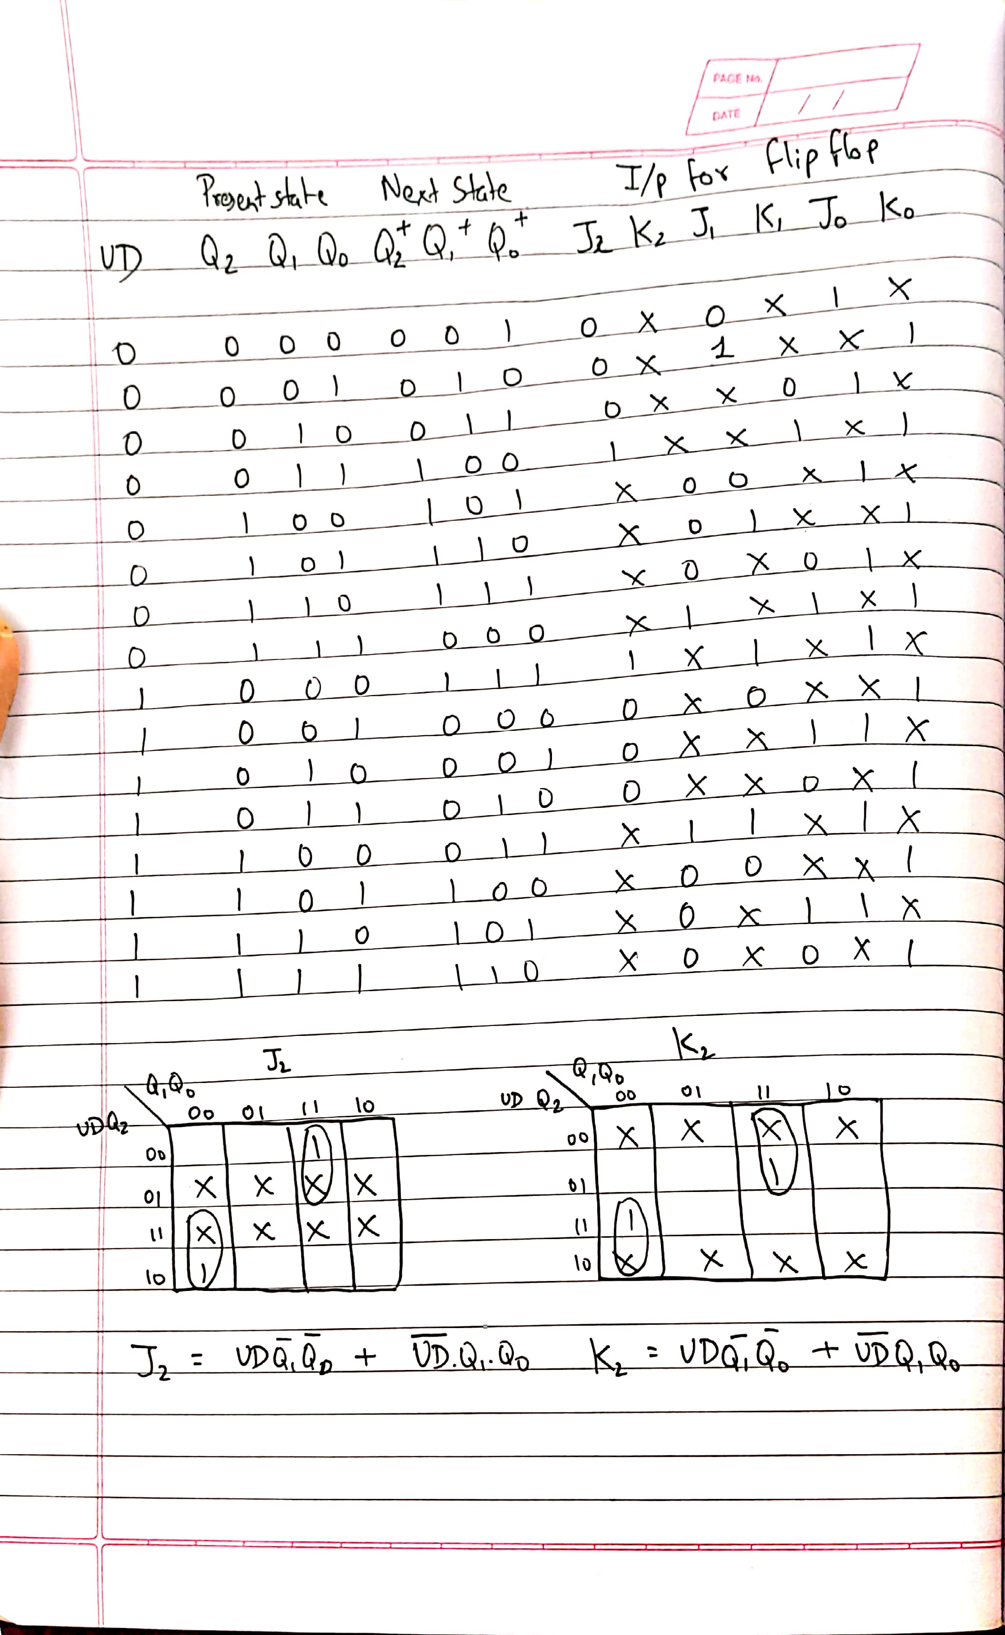

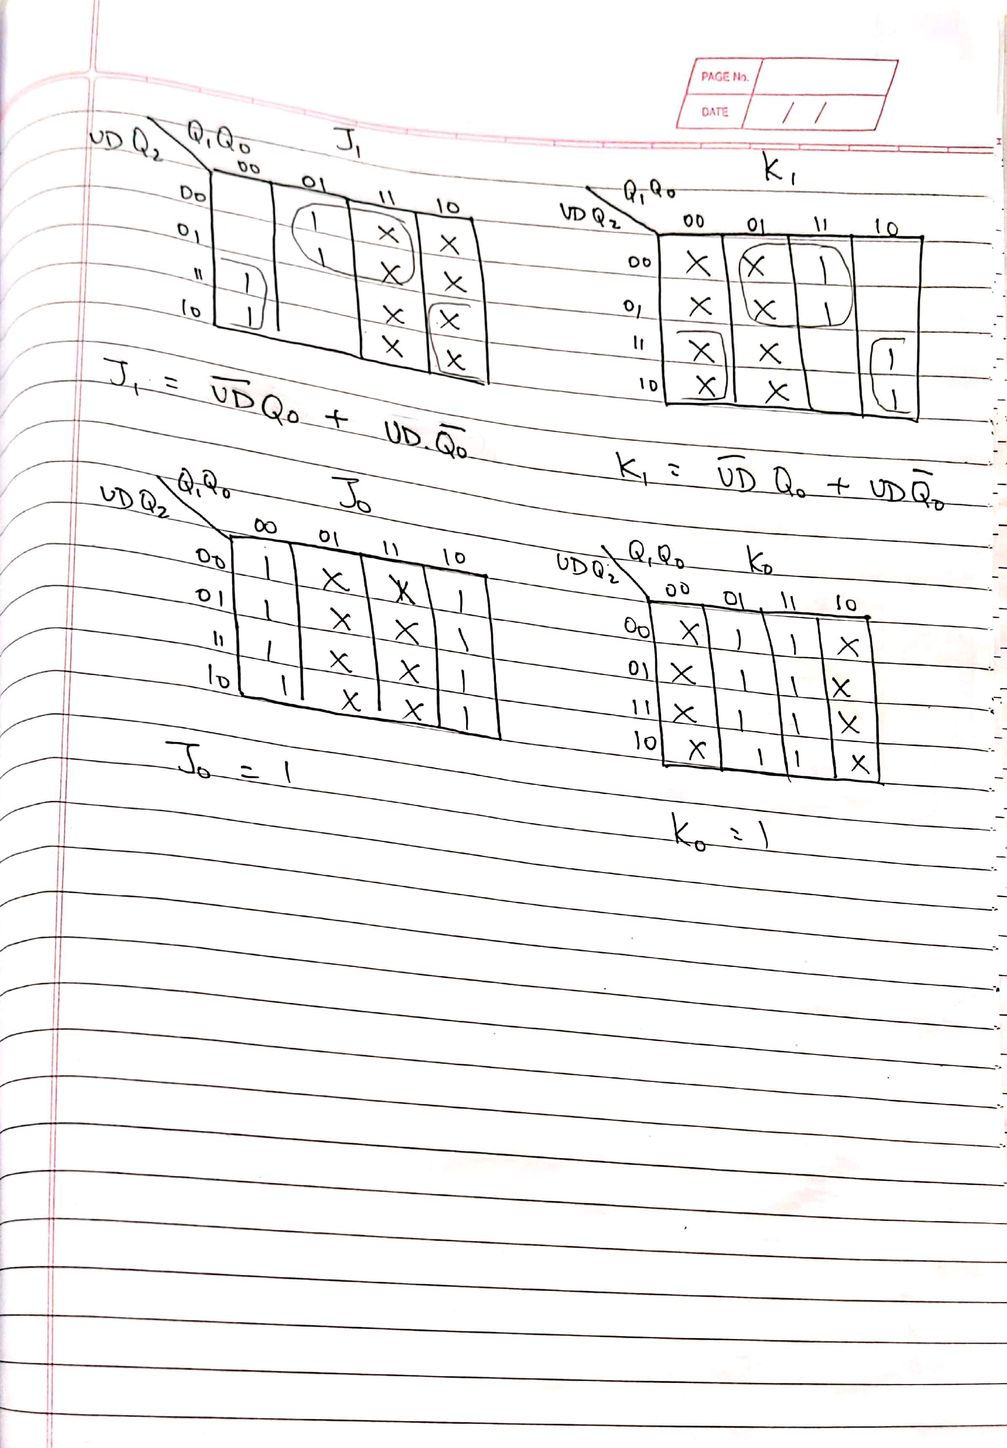_____________

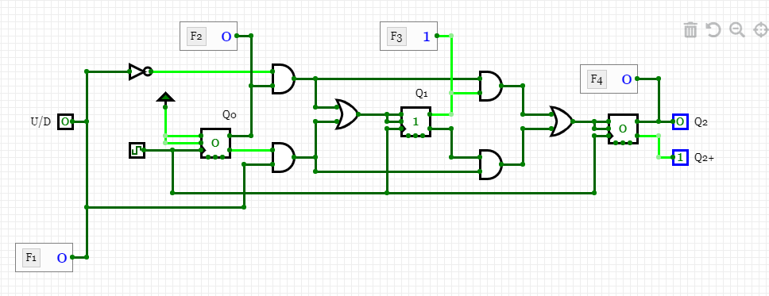

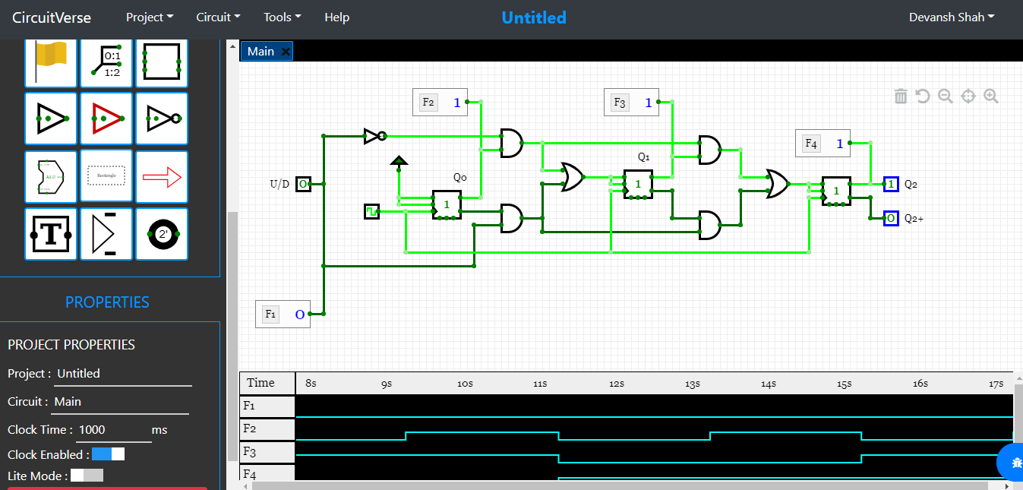

_________________________________________________
Outcomes: Design the combinational and sequential circuits using basic building blocks and MSI devices.

___________________________________________________________________________
Conclusion: We implemented 3 bit synchronous up-down counter using JK flips flops

Grade: AA / AB / BB / BC / CC / CD /DD

Signature of faculty in-charge with date
___________________________________________________________________________
References:
Books/ Journals/ Websites:
- R. P. Jain, “Modern Digital Electronics”, Tata McGraw Hill.
- http://www.electronics-tutorials.ws/counter/count_4.html

